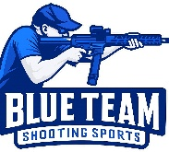
Blue Team Shooting Sports A.S.S.S. January 27th 2026
COURSE DESIGNER: Ike Starnes

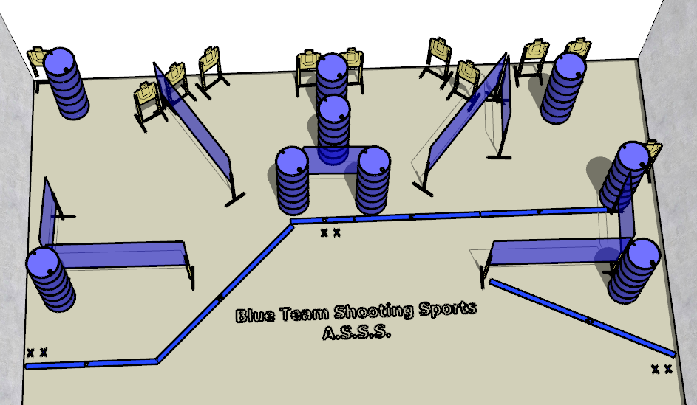

Written Stage Briefings:

Stage 1 – I drink your milkshake - is a 22-round, 110 point, Comstock Course. There are 11 cardboard targets. The best 2 hits per cardboard target will be scored.
Handgun start position Feet on left Xs. The handgun is loaded and holstered.
PCC start position Feet on left Xs. PCC is loaded with stock touching belt.
On the audible start signal, engage all targets from within the shooting area.

Stage 2 – I have a competition in me. I want no one else to succeed. - is a 26-round, 130 point, Comstock Course. There are 11 cardboard targets. The best 2 hits per open cardboard target will be scored. The best 3 hits per hardcover will be scored.
Handgun start position Feet on right Xs. The handgun is loaded and holstered.
PCC start position Feet on right Xs. PCC is loaded with stock touching belt.
On the audible start signal, engage all targets from within the shooting area.

Stage 3 – I’m finished. - is a 22-round, 110 point, Comstock Course. There are 11 cardboard targets. The best 2 hits per target will be scored.
Handgun start position Feet on center Xs. The handgun is loaded and holstered.
PCC start position Feet on right Xs. PCC is loaded with stock touching belt.
On the audible start signal, engage all targets from within the shooting area.

